Updated Demo

Paul Siebenaler

04/22/24

Sending a public message
- First the user enters what they want to say in the chat box
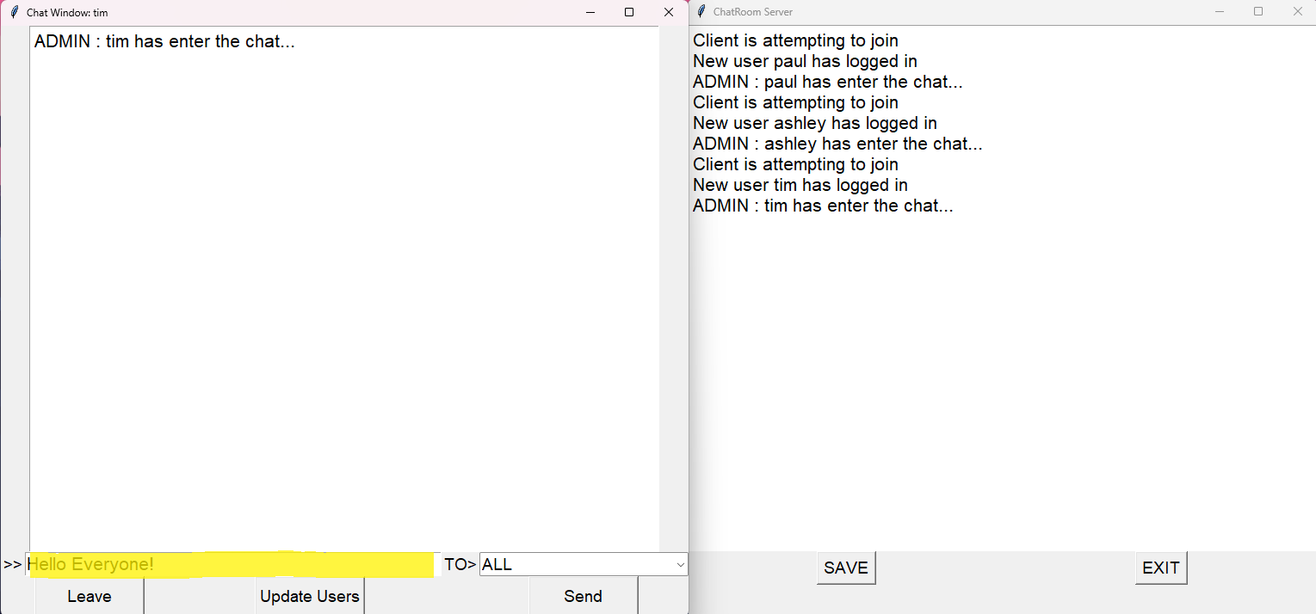
- Next the user will select who to send the message to:
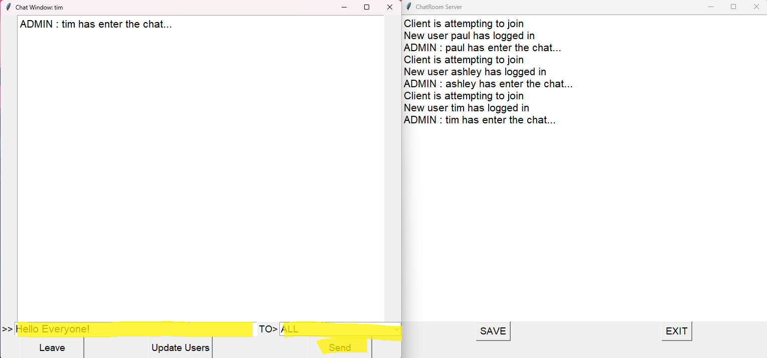

-Then Send is clicked and the message is sent to all active users
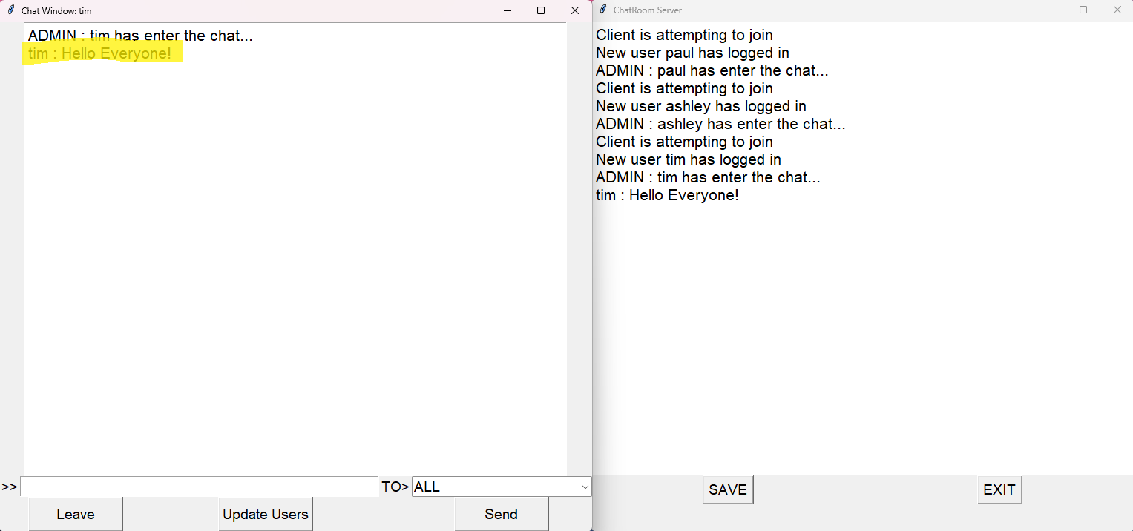
- Other users receiving the public message from tim
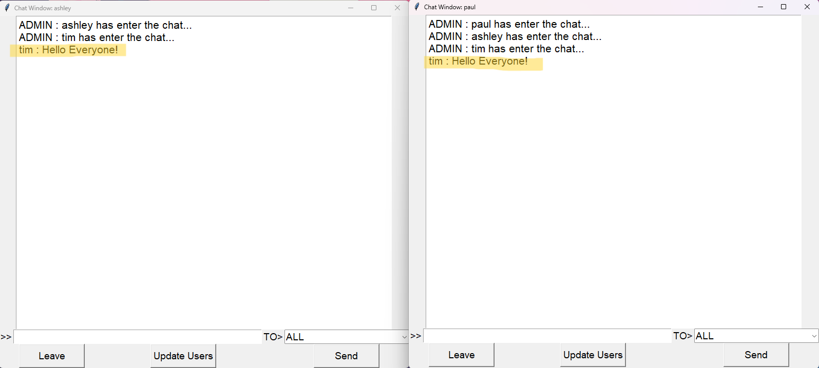
-

- Other users preparing to send a public message to all users connected
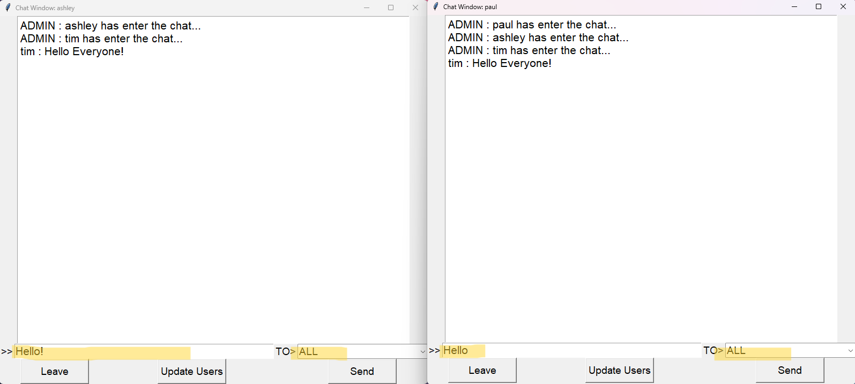
-Users receiving public messages
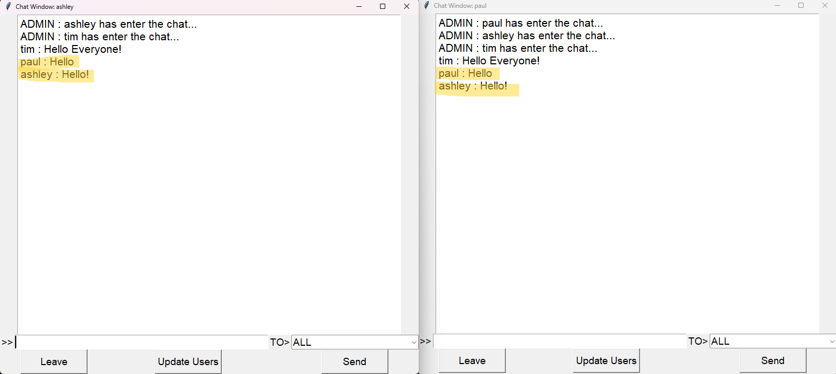

- Other users receiving public message and server recording this
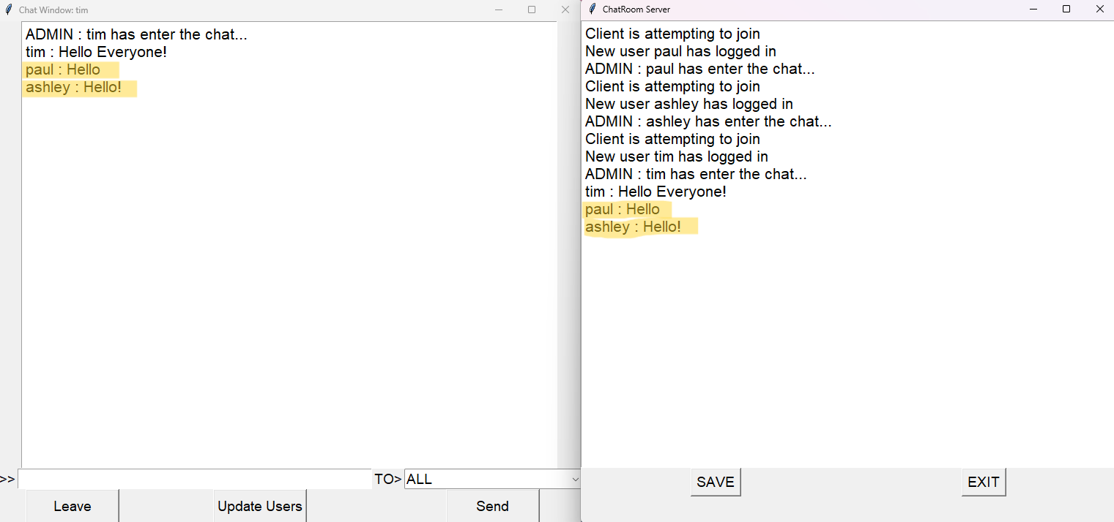
Sending a Direct message
- User selects the dropbox and selects a user to send a direct message to
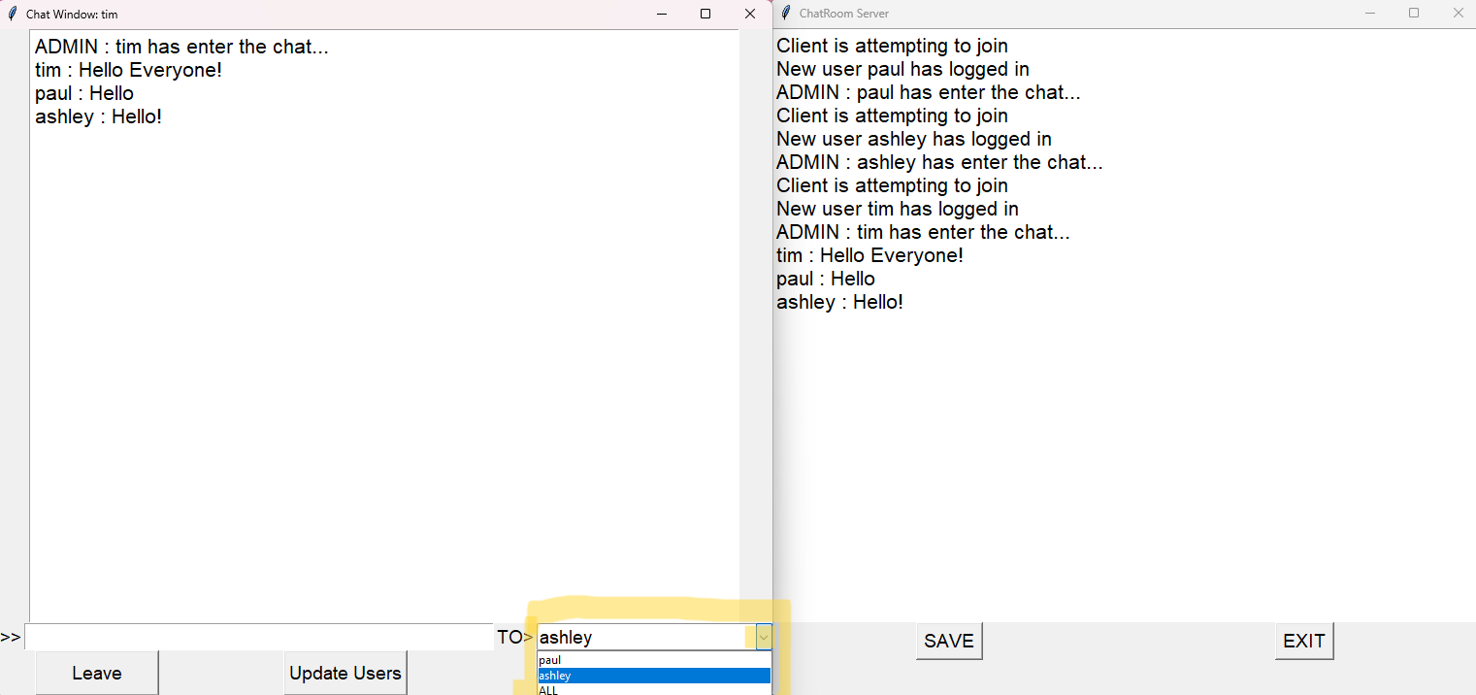

-Tim is preparing a direct message to paul
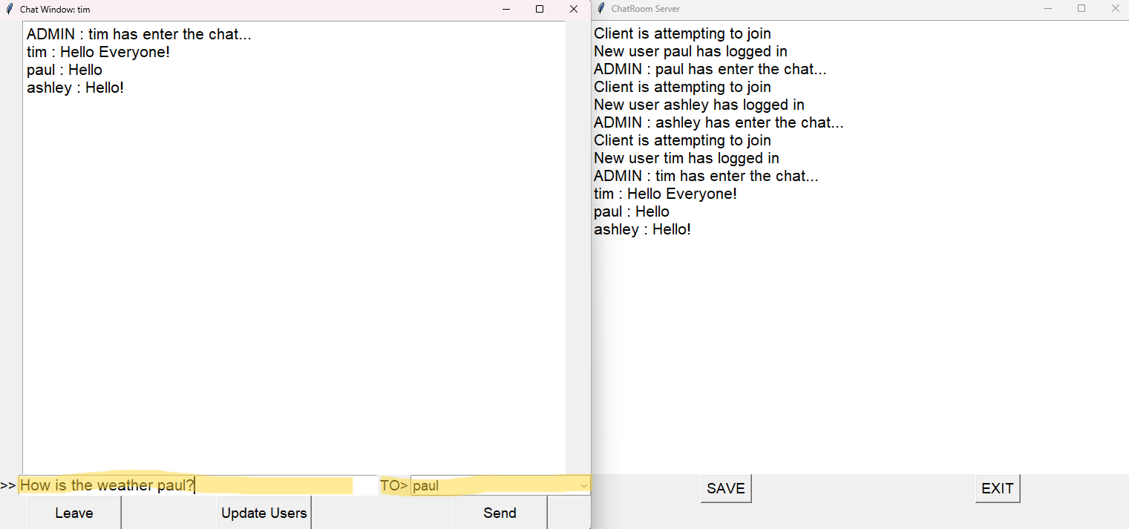
- Once message is typed the user clicks send and a direct message will be sent to the target
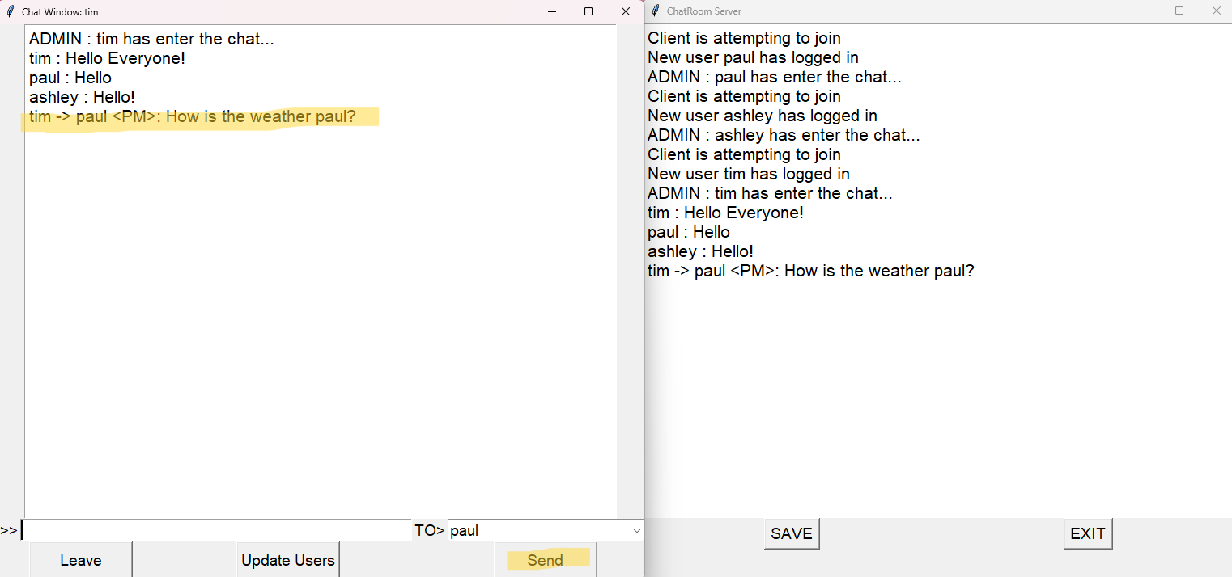

-paul received the direct message and ashley did not
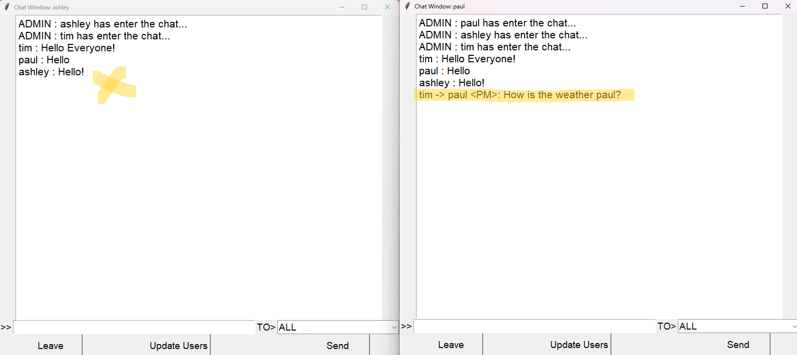
- Next ashley will prepare a direct message for paul
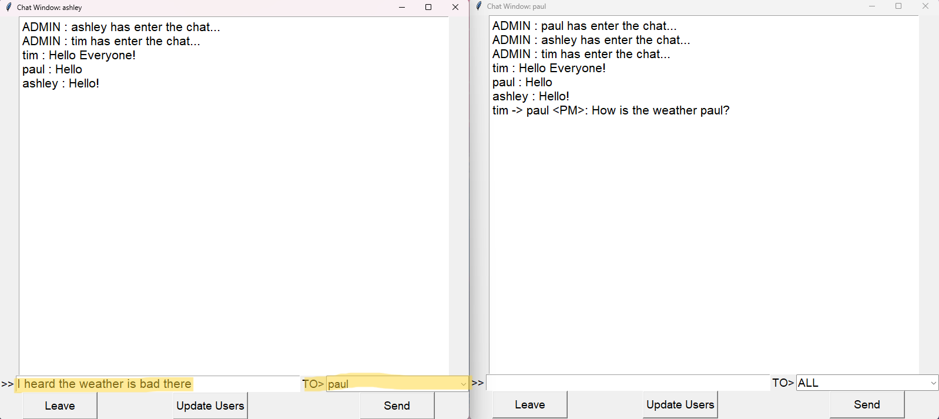

- Direct message is sent to paul. Paul can see the two direct messages sent to him
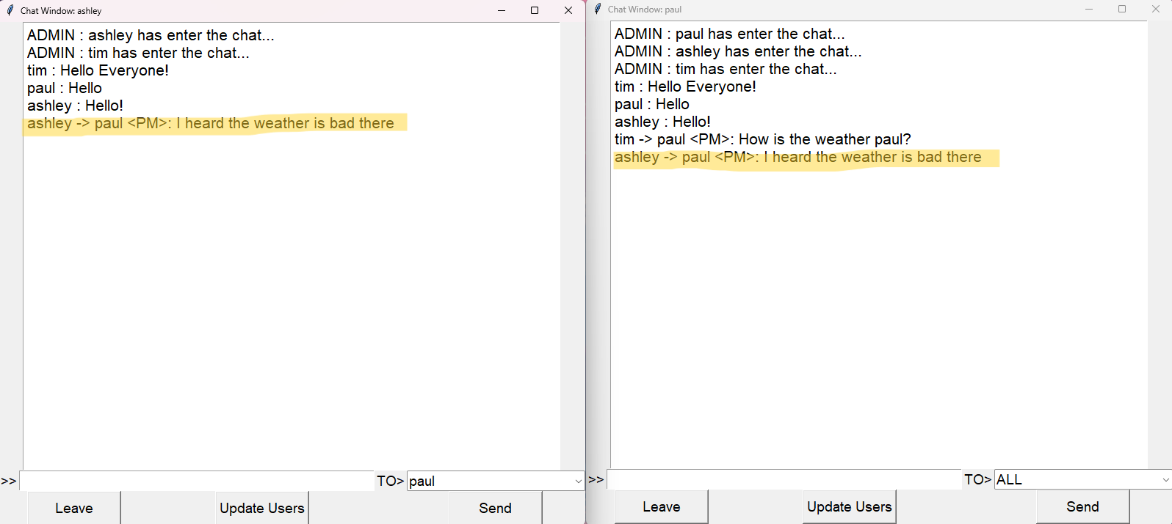
- tim only sees direct message he sent to paul, but not the message ashley sent to paul
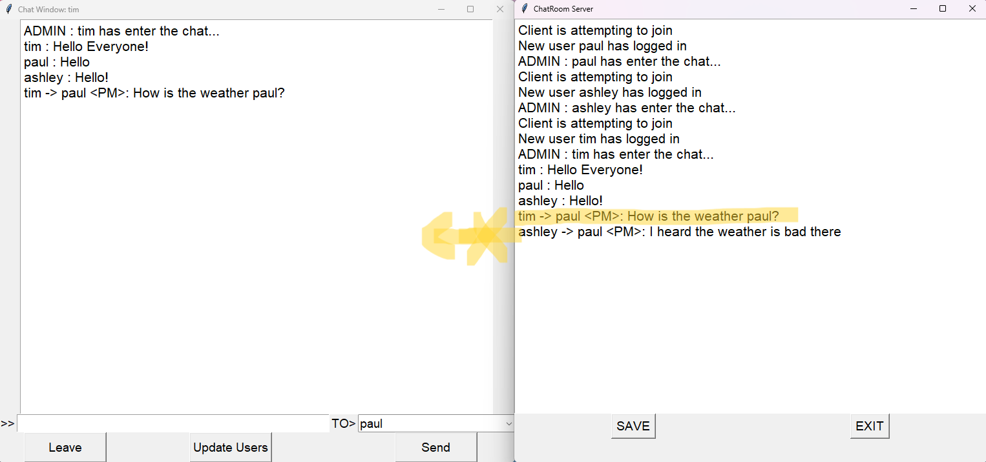

Final public messages
-user prepares a message and selects ALL users to receive the message
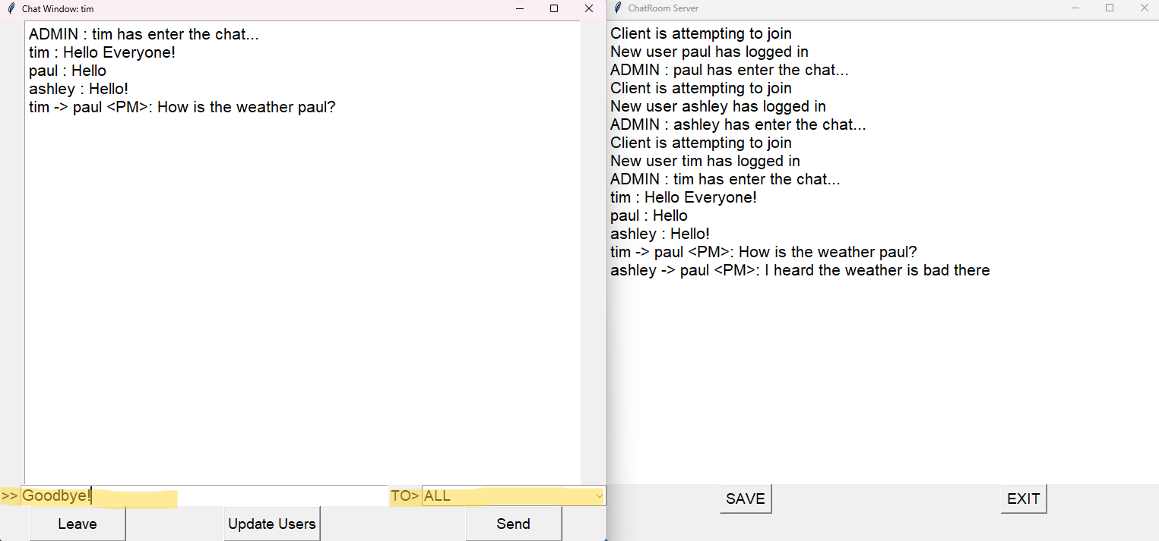
- Public message is sent and this is reflected on the server
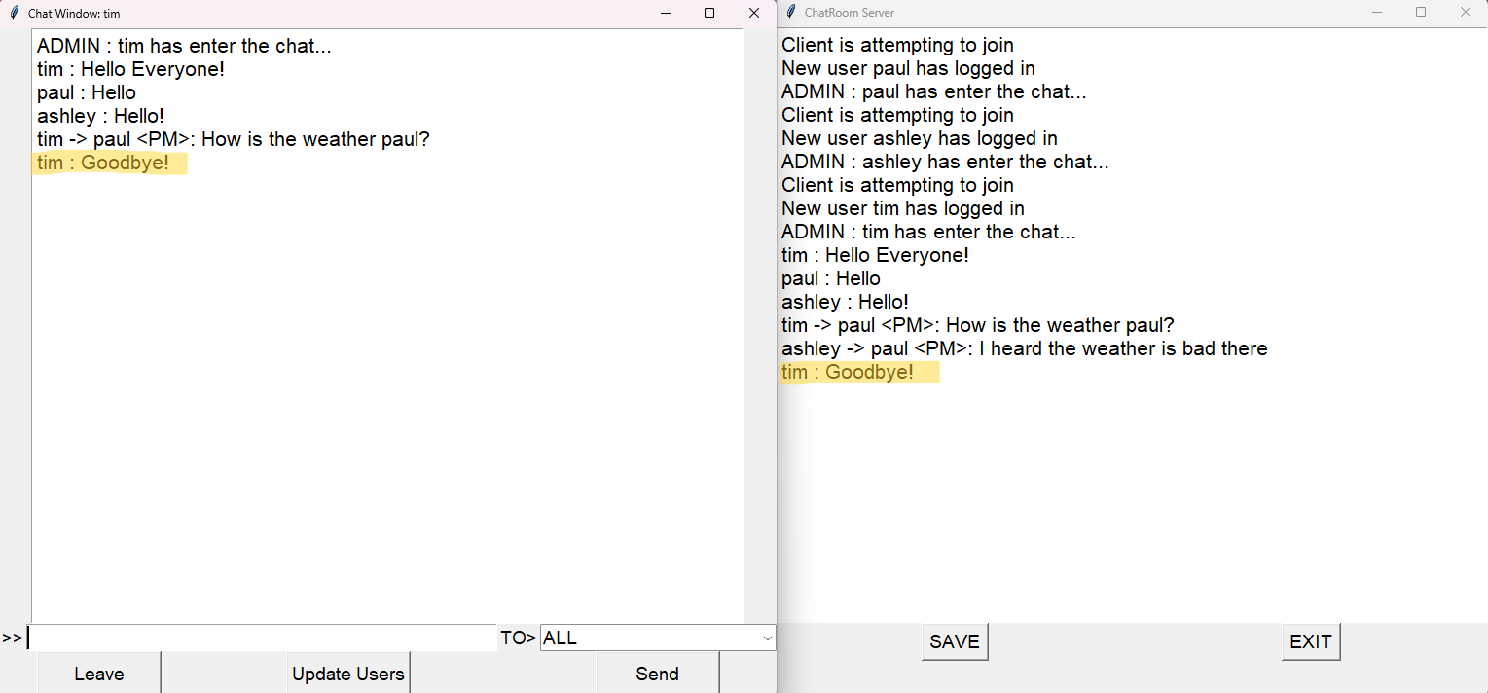

- Other users receiving public message sent from tim
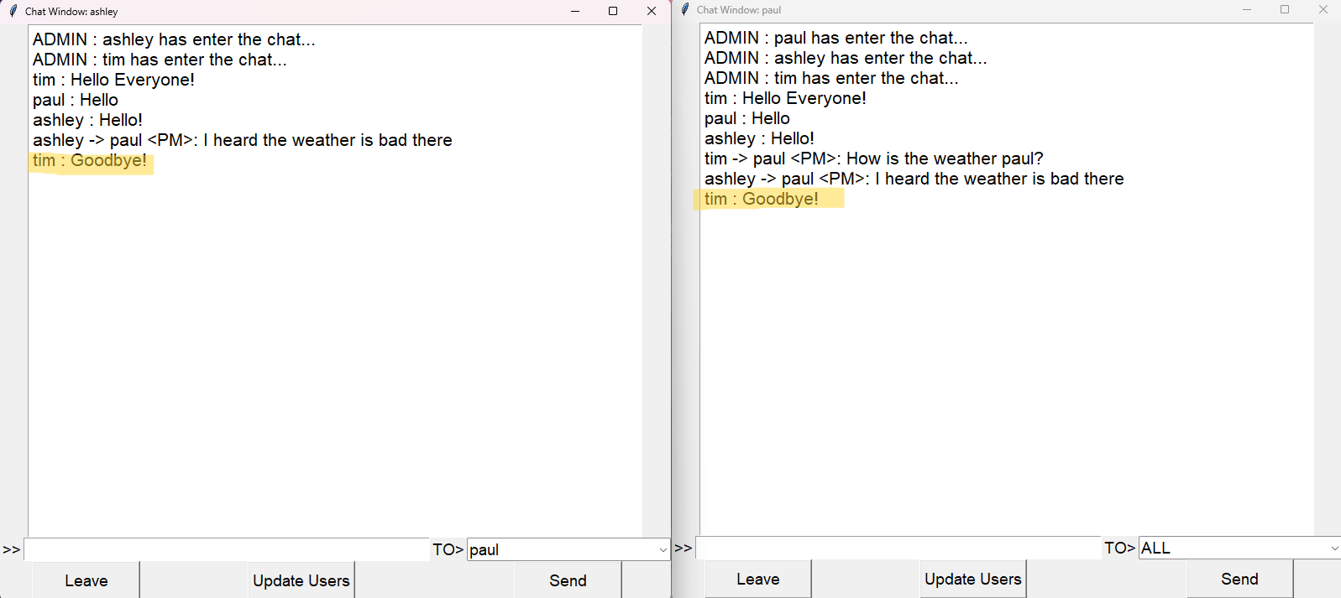

Final Chat Log
- public messages are displayed as: <username> : <message>
- direct messages are displayed as: <Sending username> → <receiver username> <PM>: <message>
*only sender, receiver and the server can see direct messages

